Benchmark Review
Geology:
- Erosion is one of the processes involved in the formation of sedimentary rock. Which of these best describes the process of erosion?

- Rocks are broken into smaller pieces that remain in the same location
- Pressure compacts layers of sediment and turns them into rock
- Pieces of rock or soil are carried from one place to another
- Sediment grains fall to the bottom of a lake to form sedimentary layers.

- The San Andreas fault is a transform fault. The map below shows a student’s approximation of where the fault line crosses through the United States. Students were asked to make maps predicting which way land would most likely move over thousands of years.
Which map best predicts the likely movement of land along the fault line over thousands of years?

- Which diagram best represents the type of tectonic plate activity that would most likely form an ocean basin?
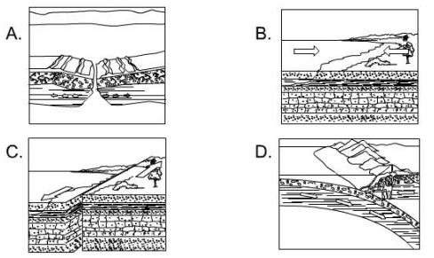

- The map below shows the locations of four active volcanoes in the Caribbean Sea.
Volcanoes in the Carribean
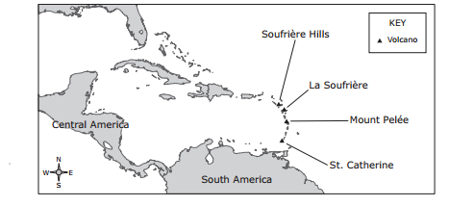
What do these volcanoes indicate about plate tectonics in the region?

- The volcanoes form an island arc, indicating a converging plate boundary.
- The volcanoes form a line, indicating a diverging plate boundary.
- Two plates are moving past each other, causing faulting and magma formation.
- Two plates are moving apart, creating new seafloor.

- Look at the cross sections in the illustrations. Which would be the best model of Earth’s structure?

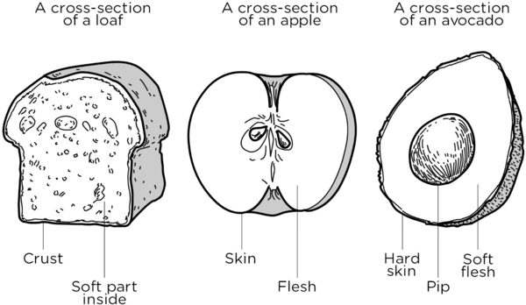
  - Loaf of bread
  - Apple
  - Avocado

- The Himalayan Mountains are shown on the map below.
Four students were asked to identify the geologic process that caused this mountain range to form. Their responses are shown below.
Which student correctly identified the geologic process that formed the Himalayan Mountains?
- Student 1
- Student 2
- Student 3
- Student 4

- How does the inner core differ from the outer core?

  - The inner core is solid, the outer core is liquid
  - The inner core is liquid, the outer core is solid
  - The inner core is divided into plates, the outer core is not
  - The outer core is divided into plates, the inner core is not

- Which of the following is associated with Earth’s Lithosphere?

- Crust, Core
- Crust, upper mantle
- Inner Core, Outer Core
- Outer Core, Lower Mantle

- Label the plates:
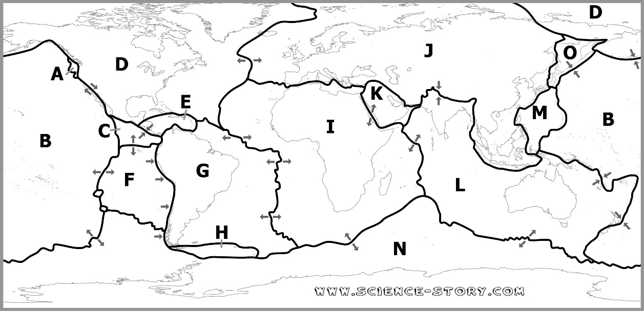
Major Plates |  | Minor Plates:
I. | L. | K. | A.
N. | D. | E. | M.
J. | G. | C. | H.
B. |  | F. | O.

Energy:
- Which of these is a renewable resource?

  - Gasoline that contains some alcohol
  - Wind produced by the uneven heating of Earth’ surface
  - Natural gas pumped from deep underground
  - None of these

- A teacher rubbed a match against a piece of sandpaper. The match started to burn. Which statement best describes the energy changes that occurred?

  - The chemical energy stored in the match changed to thermal energy and light energy.
  - The thermal energy stored in the match changed to light energy and chemical energy.
  - The light energy and thermal energy stored in the match changed to mechanical energy.
  - The light energy and thermal energy stored in the match changed to chemical energy.

- In which kind of power plant, is no fuel burned to make the steam that runs the turbine?
  - Coal Power Plant
  - Geothermal Power Plant
  - Natural gas Power Plant
  - Biomass Power Plant

- The main parts of a working clothes dryer are shown in the diagram. This appliance dries clothes primarily by converting-
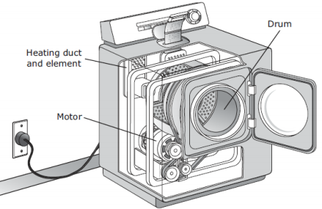
  - Electrical energy to thermal and mechanical
  - Mechanical energy to thermal and electrical
  - Electrical energy to thermal and radiant
  - Mechanical energy to thermal and sound

- The diagram below shows a hot air balloon rising. Propane gas tanks are seen at the bottom of the baloon.
What energy transformations occur when propane gas is used to lift the balloon?
  - Mechanical lightchemical
  - Chemicalmechanicalthermal
  - Thermalchemicallight
  - Chemicalthermalmechanical
Physics:
- The graph below shows the motion of a ball rolling on a straight track.
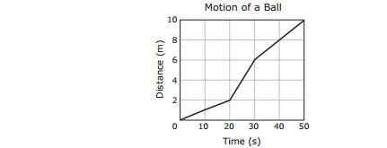
What was the ball’s average speed during the time represented in the graph?
- 0.2 m/s
- 0.5 m/s
- 5.0 m/s
- 10.0 m/s

- Two students are working together to build a birdhouse. Student 1 applies a force of 10 N to a wooden board in order to slide across the table to Student 2.
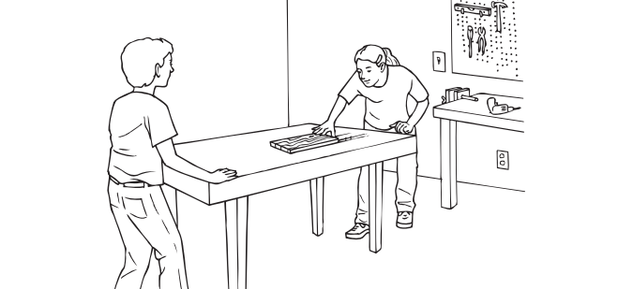
If the force of friction resisting the student’s push is 4 N, what is the net force acting on the board?
- 4 N
- 6 N
- 10 N
- 14 N

- A hobbyist collected data about the motion of a toy train on a straight track and then recorded the data in the graph below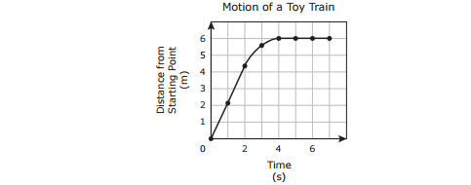
Which of the accurately describes the motion of the toy train?
  - The toy train speeds up while going forward and then slows down.
  - The toy train slows down whil going forward and then moves backwards.
  - The toy train moves forward at a constant speed, slows down, and then stops.
  - The toy train moves forward at an increasing speed, stops, and then moves forward.

- A student drew the diagram below to show the movement of water through a hydroelectric dam.
The student used the diagram to describe changes in the potential and kinetic energy of the water. At which location is the gravitational potential energy of the water the greatest?
- Location W
- Location X
- Location Y
- Location Z

- A bus travels 20 km in 30 minutes. What is the average speed of the bus?
  - 20 km/h
  - 30 km/h
  - 40 km/h
  - 50 km/h

- The list includes six situations.
Which object in the list experience an unbalanced force?
A. The book, the ball and the car.
B. The ball, the car, and the bird.
C. The can, the swing, and the bird.
D. The book, the ball, the can, and the swing.

- The drawing shows two identical airplanes at an air show. The airplanes are flying at the same speed. Airplane W is flying 50m higher than Airplane X. 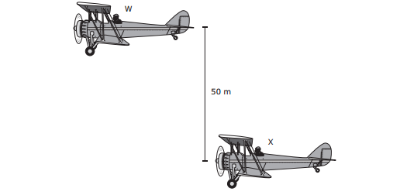
Which statement best describes the energy of the two airplanes?
  - Airplane W has a greater kinetic energy than Airplane X.
  - The two airplanes have the same gravitational potential energy but different kinetic energies.
  - Airplane X has more gravitational potential energy than airplane W.
  - The two airplanes have the same kinetic energy but different gravitational potential energies.

Biology:
- A student observing birds in a park records some ways the birds interact with living and nonliving parts of their environment. All the following observations are ways that a bird interacts with nonliving parts of its environment except—

  - Reacting to morning sunlight by singing.
  - Drinking and taking a bath in a puddle of water.
  - Responding to cold temperatures by fluffing its feathers.
  - Feeding insects to its chicks.

- Plants use energy from sunlight, water, and carbon dioxide to produce sugar. Which structure is found only in plant cells and helps plants capture energy from sunlight?

  - Vacuole
  - Nucleus
  - Chloroplast
  - Cell membrane’

- The hydra is a very small, simple animal that lives in water. Hydras reproduce asexually by budding, a process in which a bud breaks off an adult hydra and floats away.
Which of the following best describes a hydra bud?
- A hydra bud contains genetic material from its two parents.
- A hydra bud is genetically identical to the parent hydra.
- A hydra bud has different mutations that the parent hydra.
- A hydra bud has half as much genetic material as the parent hydra.

- A group of students prepared a table listing the types of reproduction that occur in several organisms.
Based on this information, which of the organisms can produce offspring that are genetically identical to the parent organism?
- Ferns only
- Amoebas and yeasts only
- Cats, hydras, frogs, and ferns only
- Amoebas, yeasts, hydras, and ferns only

- Data for four animal populations in a wooded area were collected before and after a shopping mall was constructed near the area. The graph shows changes in the populations.
Which animals’ food sources most likely increased after the mall opened?
A. Snakes, squirrels, and raccoons | C. Snakes, squirrels, and deer
B. Squirrels only | D. Raccoons only
Chemistry:
- Some students are using samples of difference substances for a lab investigation. They plan to observe the physical properties of each substance and record their observations in a table like the one below.
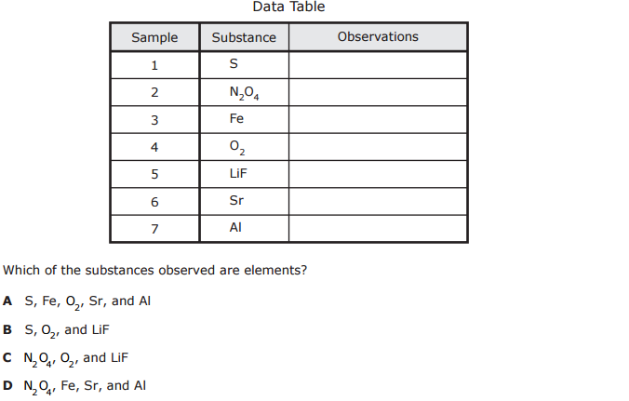
- What is the difference between the number of electrons in an atom of selenium, Se, and the number of electrons in an atom of aluminum, Al?

- A chemist is identifying the elements present in a sample of seawater. What characteristic of an element’s atoms always determines the element’s identity?

  - The number of protons
  - The number of neutrons
  - The location of valence electrons
  - The number of valence electrons

- For an investigation a student records data about four unknown substances.
The student then calculates the densities of the unknown substances and compares them with the table of densities of known substances shown below.
Which unknown substance is most likely carbon?
- Substance 1
- Substance 2
- Substance 3
- Substance 4

- Some students conducted a laboratory investigation to learn more about the physical properties of different elements. They observed four samples and recorded their observations in the table below.
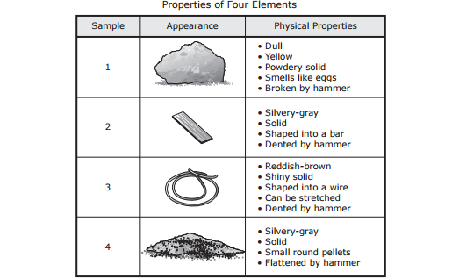
Based on these observations, which sample is most likely a nonmetal?
- Sample 1
- Sample 2
- Sample 3
- Sample 4

